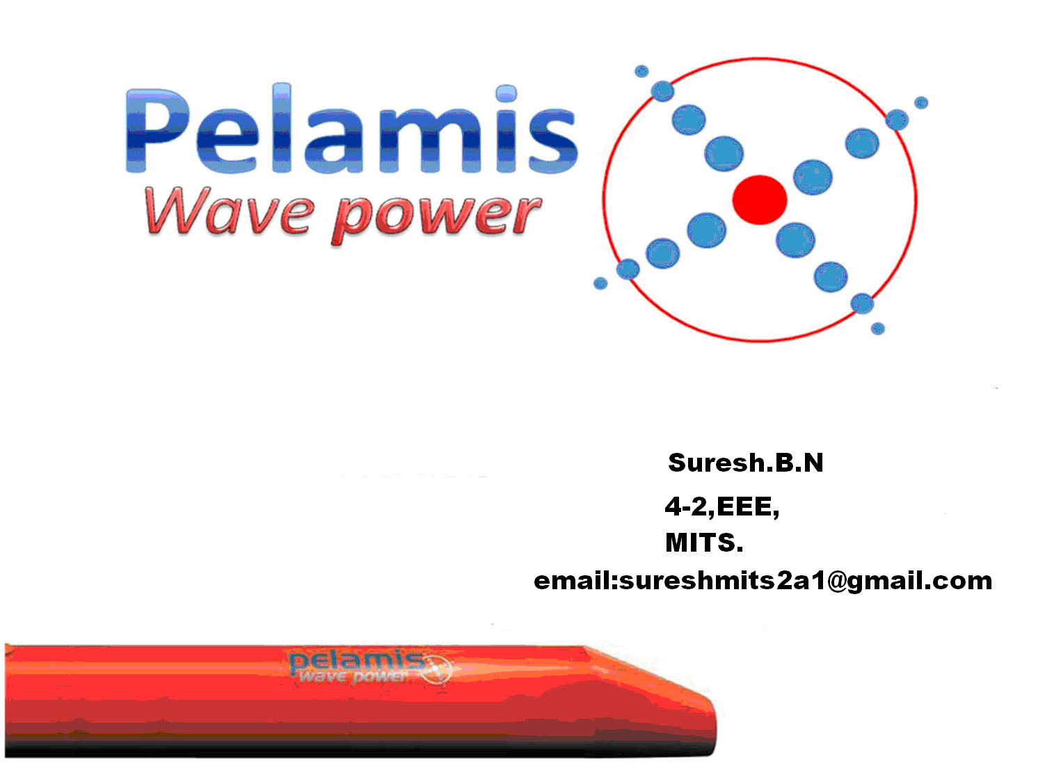

ABSTRACT:
Pelamis is the world’s first commercial scale machine to generate electricity into the grid from offshore wave energy and the first to be used in commercial wave farm projects.
It is massive, red, steel tubes look like rounded train cars used to generate electricity from the sea waves. Pelamis is actually the name of a surface swimming sea snake, which is quite an apt description for the machine when you see how it moves.
It developed by a Scottish company, PELAMIS WAVE POWER founded in 1998 by Dr Richard Yemm, Dr Dave Pizer and Dr Chris Retzler
Pelamis is actually the name of a surface swimming sea snake, which is quite an apt description for the machine when you see how it moves.
The Technology:
- It is based on Buoyancy forces.

- The wave-induced motion of these joints is resisted by hydraulic rams, which pump high-pressure oil through hydraulic motors via smoothing accumulators.

- The hydraulic motors drive electrical generators to produce electricity.

The structure:
The Pelamis contains three Power Conversion Modules, each rated at 250kW. Each Power Module contains a complete electro-hydraulic power generation system. 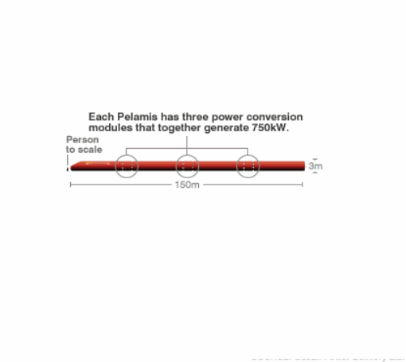
How does it work?
The machine is held in position by a mooring system at its nose. It maintains enough restraint to keep the pelamis positioned but allows the machine to swing head on to on coming waves.
Each pelamis has three power conversion modules and each module has hydraulic ram, reservoir, manifold, etc;
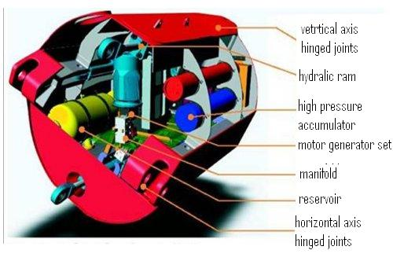
The three power modules of it are joined by tubular sections.
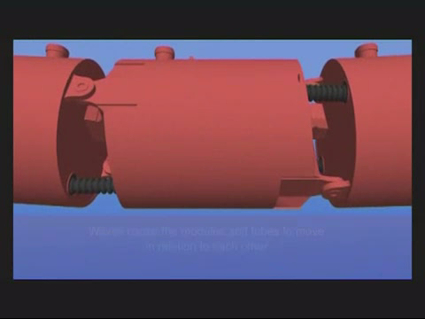
Wave causes the modules and tubes to move in relation to each other.

The motion is resisted by hydraulic rams in each of the joints.
The hydraulic ram pumps the high pressure oil trough hydraulic motors.

The hydraulic motors drive electrical generators to produce electricity.
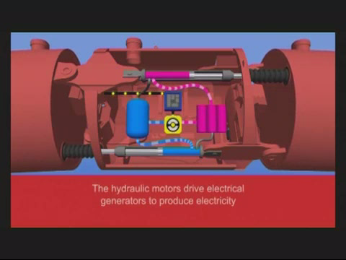
Each module is designed to produce 250Kw, so each pelamis produce 750Kw power.
Power from all the joints is fed down a single umbilical cable to a junction on the sea bed. Several devices can be connected together and linked to shore through a single seabed cable connected to a transformer in the machine’s nose.
.
Top view:
Side view:

To produce more power the pelamis are interred linked.
A novel joint configuration is used to induce a tunable, cross-coupled resonant response, which greatly increases power capture in small seas.
Control of the restraint applied to the joints allows this resonant response to be ‘turned-up’ in small seas where capture efficiency must be maximized or ‘turned-down’ to limit loads and motions in survival conditions.
Production:
The production of Pelamis WECs is split into three significant phases:
- Power Module fabrication, population and commissioning
- Tube, Nose and Yoke fabrication, population and commissioning
- Final Assembly and pre-installation commissioning
Once assembled, the Pelamis machines undergo commissioning and sea trials prior to their installation.
Power Module Fabrication, Population and Commissioning
The power conversion modules contain the power capture systems. The module consists of a fabricated and painted steel structure that is populated with systems that include motor generator set, hydraulic cylinders, accumulators, reservoirs and electrical control cabinets. These systems are delivered to the module population facility where they are installed, assembled and the completed power conversion module commissioned.
Tube Fabrication, Population and Commissioning
The main structural fabrication consists of steel tubes, nose and yoke sections. The nose section is installed with transformer, switchgear and control systems and is commissioned. Each tube is fitted with cabling and connecting transits as well as ballast to ensure the correct displacement and trim of the machine.
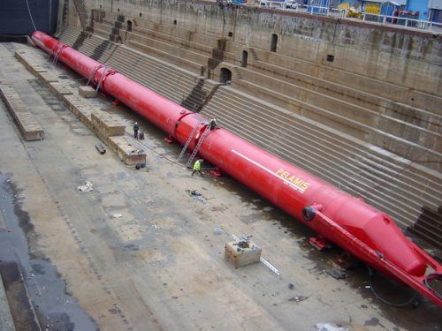
Final Assembly, Testing & Commissioning
The completed module and tube segments are joined together to complete the assembly of the machine. These joints can be made both on land and in the water depending on the facilities used.
The fully assembled machine then undergoes quayside commissioning prior to sea-trials and on-site installation at the wave farm.
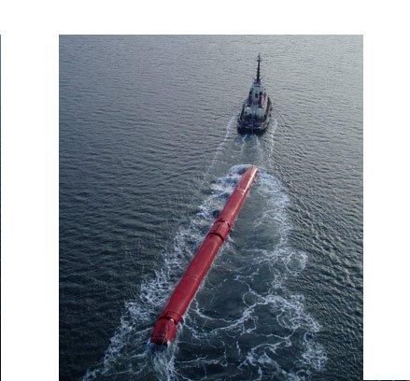
Materials:
There are smaller quantities of various other metals and materials which make-up the machine and its components including: copper, stainless steel, rubber, bearings and plastics.
Corrosion and Fouling Protection
Unlike a vessel, where marine growth causes drag and therefore increased fuel costs, Pelamis is stationary and any increased drag due to marine growth is negligible, therefore the system is largely tolerant of growth, meaning that harmful anti-foul ants are not required over the entire submerged structure. A marine paint coating is applied to structural steel surfaces in the atmospheric and splash zone and cathodic protection is applied to areas of the structural steel components in the submerged zone using sacrificial anodes.
Liquids/Pollutants
In the unlikely event that a leak of hydraulic fluid occurs within the power take-off module there are two levels of egress/ingress protection on all leak points, both of which would have to fail to allow water to ingress to a point where fluid could escape to the outside environment. PWP also uses biodegradable transformer fluid.

Advantages:
- Survivability ‘built in’
- 100% available technology
- No maintenance carried out at offshore site
- No offshore intervention required
- 'Hands Free' operation
- Lowest kWh costs in the market
- High return potential
Environmental impact:
- Noise emission
- Impact on marines
- Impact on birds

Conclusion:
As it is a latest renewable energy project and it helps in protecting the environment for future generations, this is very useful.
References:
www.pelamiswave.com
www.youtube.com

